VIXCOIN (PROJECT 3)  
Business Requirement Definition (BRD)   
_______________________________________________________



|  |  |
| --- | --- |
| **Author:** | Prateek Sharma |
| **Document Version:** | 1.0 |
| **Date:** | 28th Nov 2021 |

|  |  |
| --- | --- |
| **Product Owner:** | Prateek Sharma |
| **Project Manager:** | Jasmine Tengsico |
| **Lead Developer:** | Jason Garcia |
| **Finance Data Scientist:** | Paola Carvajal |
| **Smart Contract Developer:** | Srini Goda |

**Project Definition:**

VixCoin is a decentralized finance company, which develops dApps based on the Ethereum Blockchain that enables users to invest in a digital token "VixCoin" that utilizes information from a machine learning enhanced algorithm trading strategy stock futures such as VIXM.

VixCoin is an ethereum based Fungible Token (ERC20) which allows investors to buy/sell the coin on VixCoin front-end portal in order to invest in VIXM index fund. Where, VixCoin's financial advisors invest the money in VIXM by using various Algorithms with the help of Machine Learning Model to predict Buy/Sell signals to make profits in each trade.

VIXM is a measurement of volatility in futures prices of the market index, VixCoin i.e. ERC20 token does allow investors around the world to buy/sell the VixCoin to book profit by withdrawing at their ease. As an MVP (Minimum Viable Product), VixCoin Portal does allow the investors to perform following activities:

* Buy/Sell VixCoin
* Manage Portfolio in Summary Section
* View Transaction History

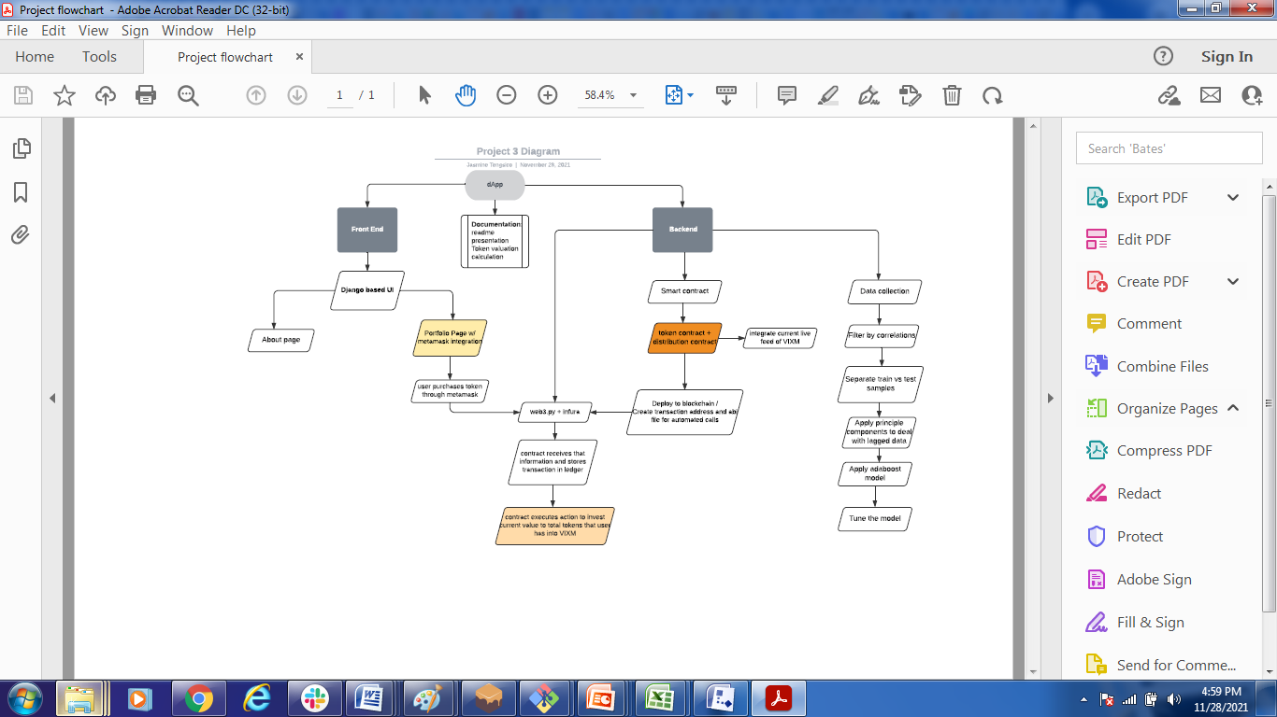

Fig. 1 (End-to-End Flow)

Fig .1 shows that how the end-to-end flow of each transaction covering Front-End and Back-End activities performed in VixCoin portal.

**MVP Requirements:**

**Epic# EP001:**

Build a Front-End Portal "VixCoin" where user as an "Investor" can Buy & Sell the VixCoins with the complete details of Transaction History & Portfolio Summary. In order to facilitate the transactions, Smart Contract needs to be updated to reconcile each transaction to maintain the count of Coins in back-end. VixCoin pricing determined by the signal produced each day at closing time by AdaBoost Machine Learning Model.

**Capabilities:**

**#CP001: Front-End Capabilities:**

Front-End Portal: "VixCoin" with following capabilities:

A. Buy VixCoin B. Sell VixCoin

C. Portfolio Summary Section D. User's Transaction History

**Feature# FE001**

**Feature Functionality:** Buying Functionality

**User Story# US001**

As an Investor, I want to have a functionality that:

I can buy VixCoin on front-end portal by clicking on button "Deposit" after specifying the No. of Coins to be purchased with the visibility of current Rate per Coin.

So that, Investor can buy and hold the VixCoin in his metamask wallet address.

**Acceptance Criteria:**

* On passing the value of No. of Coins to be purchased, the Coin Cost must be reflected in the second field to show the total cost incurred by buyer, otherwise it fails the purpose.
* On clicking the button "Deposit" the transaction must be completed with the updated balance in portfolio summary section and the transaction history grid must reflect the latest entry on front-end portal.

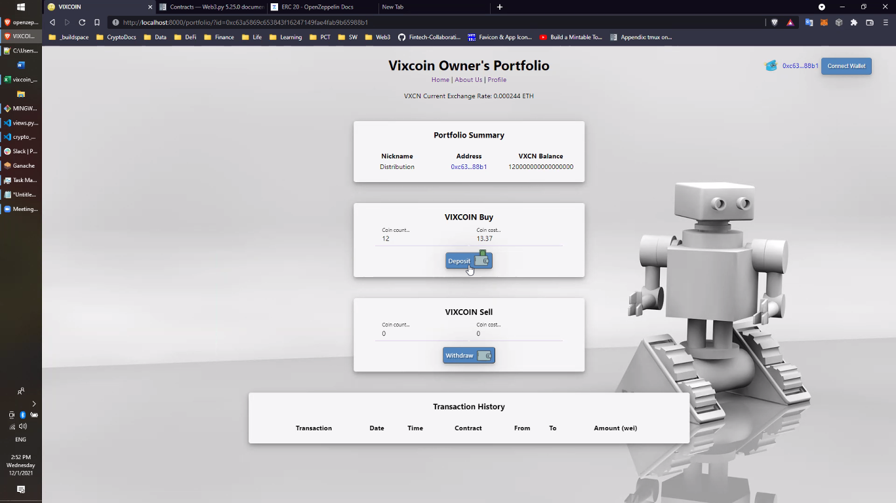

**Feature# FE002**

**Feature Functionality:** Selling Functionality

**User Story# US002**

As an Investor, I want to have a functionality that:

I can sell VixCoin on front-end portal by clicking on button "Withdraw" after specifying the No. of Coins to be sold with the visibility of current Rate per Coin.

So that, Investor can sell no. of coins entered in the field and hold the remaining balance of VixCoin in his metamask wallet address.

**Acceptance Criteria:**

* On passing the value of No. of Coins to be sold, the Coin Cost must be reflected in the second field to show the total cost of selling coins, otherwise it fails the purpose.
* On clicking the button "Withdraw" the transaction must be completed with the updated balance in portfolio summary section and the transaction history grid must reflect the latest entry on front-end portal.



**Feature# FE003**

**Feature Functionality:** Portfolio Summary Section

**User Story# US003**

As an Investor, I want to have a functionality that:

I can refer the name of my portfolio where I have invested in, with the address details & ETH balance.

So that, Investor must be aware of his portfolio details like address with amount invested in Ether.

**Acceptance Criteria:**

* On each transaction whether its Buy or Sell, the portfolio needs to be updated with the current amount in wallet address, otherwise it fails the purpose.



**Feature# FE004**

**Feature Functionality:** Transaction History

**User Story# US004**

As an Investor, I want to have a functionality that:

I can refer the history of all my past transactions with complete details like: TRX Hash, Date, Time, Contract #, Sender's Address, Recipient's Address & Amount.

So that, Investor must be aware of his all past transactions over the period of time.

**Acceptance Criteria:**

* On each transaction whether its Buy or Sell, the portfolio needs to be updated with the current amount in wallet address, otherwise it fails the purpose.

